Week: 15
Experiment:14
“Rapid Detection of Hepatitis-A(HAV) and Dengue Using Immunochromatographic Test Kits.”
Total Marks (30 Marks):
1) Lab Performance (10 Marks):
Part A: Detection of Hepatitis-A(HAV)
2) Observations (2 marks):
Lines | Present/Absent
Control line | Present
IgG line | Absent
IgM line | Absent

3) Picture of cassette (1 mark):
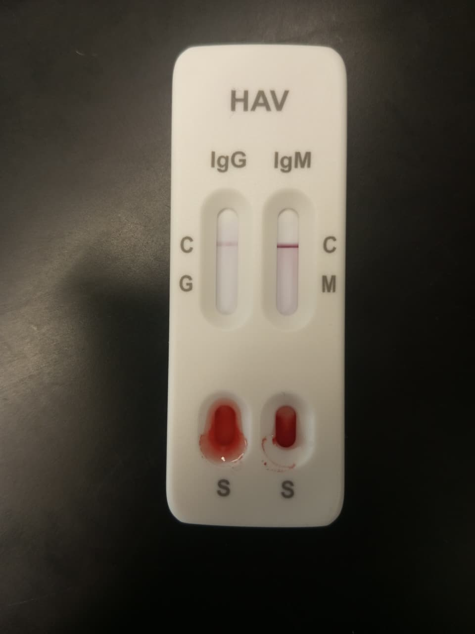

4) Results (2 mark):
Negative for Hepatitis (IgG and IgM)
- Control line visible: Test is valid.
- IgM line not visible: No detectable recent infection.
- IgG line not visible: No detectable past infection or long-term antibodies.
Meaning of the result
- You are negative for both IgM and IgG antibodies at this moment.
- This means:
  - No active infection (IgM−)
  - No past resolved infection (IgG−)

Part B: Detection of Dengue

5) Observations (2 marks):
Lines | Present/Absent
Control line | Present
Test line | Absent

6) Picture of cassette (1 mark):
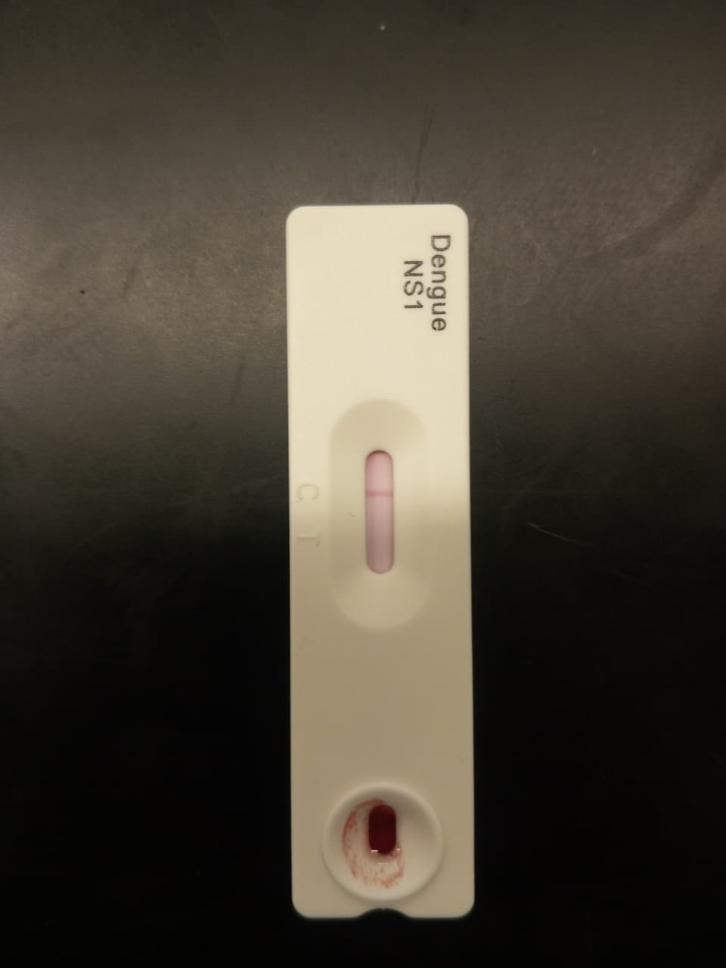
7) Results (2 mark):
Negative for Dengue
- Control line visible: Test is valid.
- NS1 test line not visible: Negative
So, the test result is considered NEGATIVE.

8) Labster Simulation (10 Marks):

9) Problems:
No such problems faced.

